Accident analysis on the falling off of engine crankshaft thrust plate
I. Fault symptom
1. Both ends of upper and lower crankshaft thrust plates are worn out, and the crankshaft thrust bearing falls off in the oil pan.
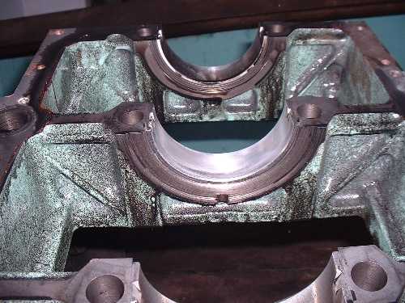

2. Friction occurs severely between working surface of flywheel and clutch disc and produces a bright frictional ribbon. The end face of spline sleeve inside the disk hub is badly worn.

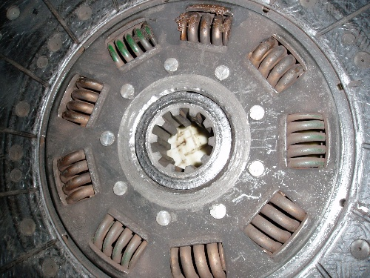

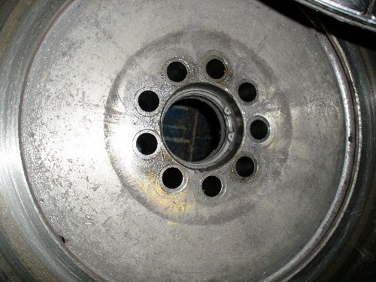
3. The clutch disc has shown the trace of slip, and the zone of slip trace is located on the outside of the clutch disc.

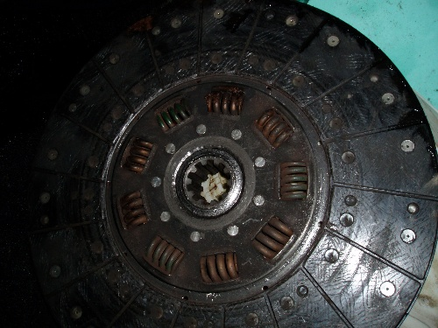
4. Severe wear appears on the guide end of shaft of gear box. The inner ring of guide bearing 6305-2RS1(radial ball bearing) of the flywheel was damaged and led to the looseness of the bearing.
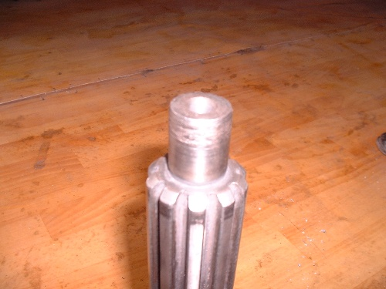
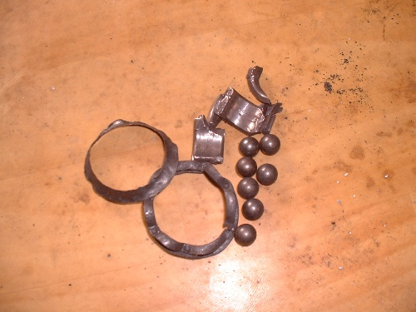
5. The release bearing seat of 11203 was broken from the working end face of the release bearing. The debris of F91409 gearbox cover can be found inside.
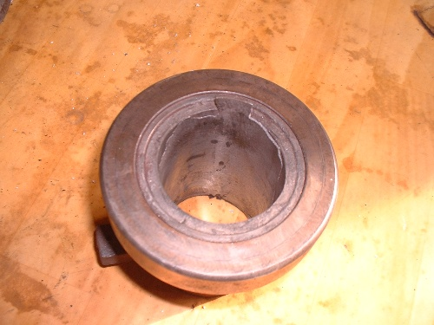

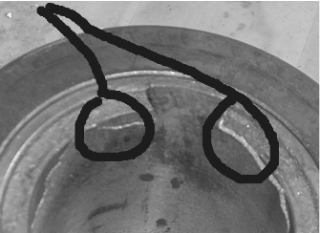
6. The input shaft cover was broken on the contact surface to the release bearing seat of 11203. The feature of the surface of fraction is: one part depressing towards inside (with a bright zone caused by impact), and the other part stretching out towards outside (with broken edge in inclined stubble).
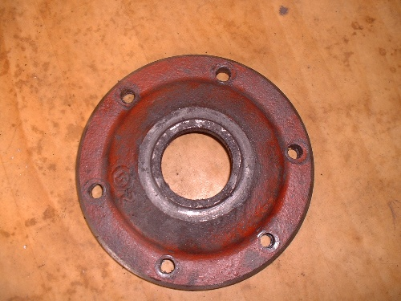

II. Accident Analysis
Crankshaft must have certain axial clearance. However, with axial clearance, the crankshaft will move suddenly forward and backward by the axial force. To restrain such movement, axial thrust plate should be mounted on the crankshaft. When the engine is operated, the wear of axial thrust plate will unavoidably occur. If the axial clearance reaches certain degree due to the wearing out of the thrust plate, a sound will be produced by impact due to the sudden movement of the crankshaft.
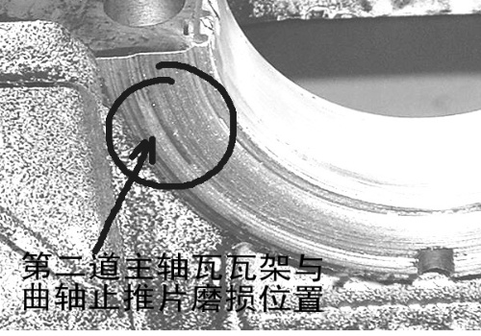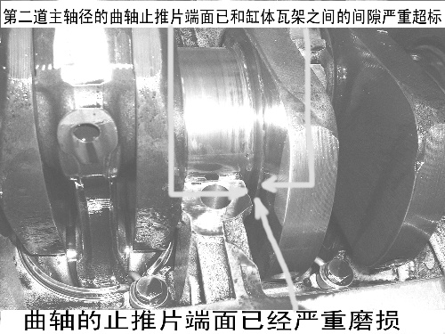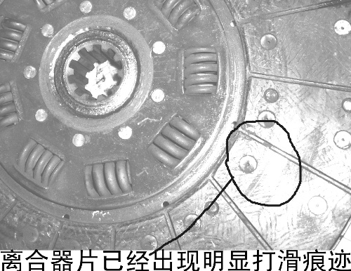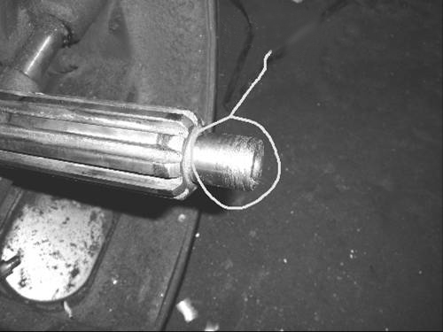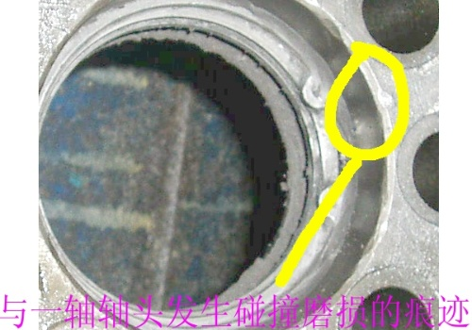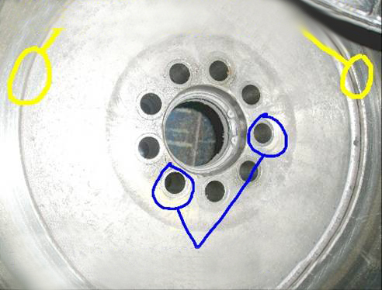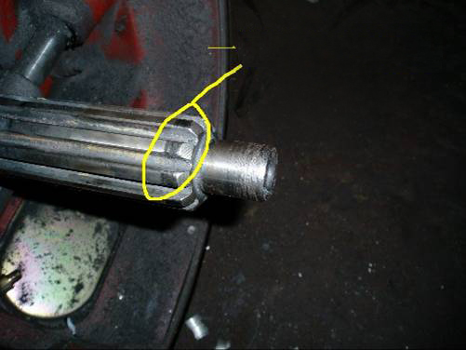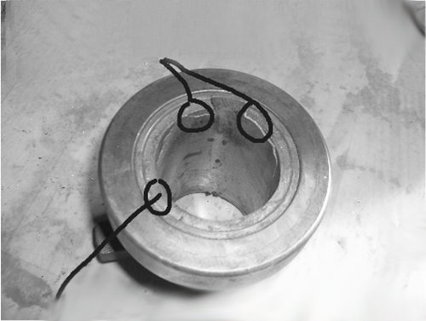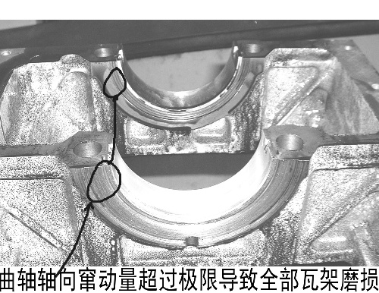
Obvious skid marks appear on Clutch plate.
Serious weight problem of clearance between crankshaft thrust plate of second rail main shaft diameters and cylinder bushing bracket
Wear position of bushing bracket of second rail main shaft diameters and crankshaft thrust plate
Trusting plate end-face of crankshaft had severe worn
Guide shaft of Main shaft had severe worn
Wear mark clashed with input shaft head
Worn Condition of Fly wheel work end-face transition area
Alternating exchange load form mark at the flywheel bolt hole
Worn position of input shaft head
Break position of 11203 release bearing seat
Remnant in the release bearing seat of input shaft cover after break, unevenly worn can be seen.
Axial movement is more than limit value, which causes worn of all bushing bracket
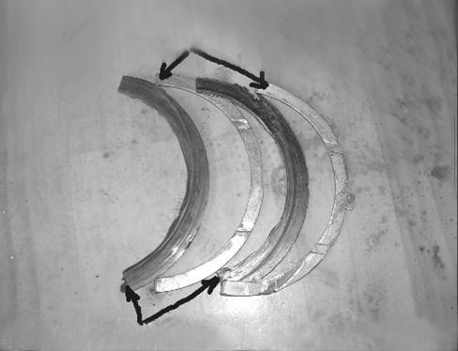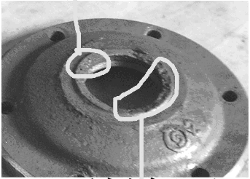
Crankshaft trusting plate dropped in the oil sump

Crankshaft trusting plate dropped in the oil sump

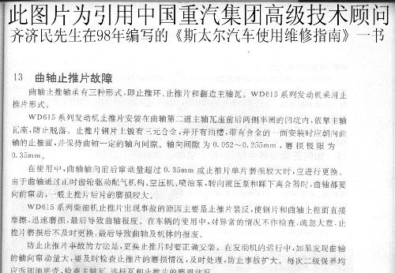
III. Causes of the Accident
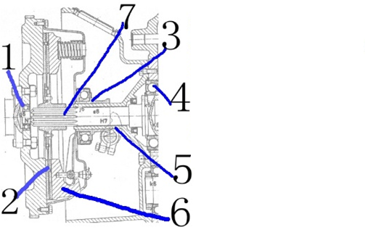
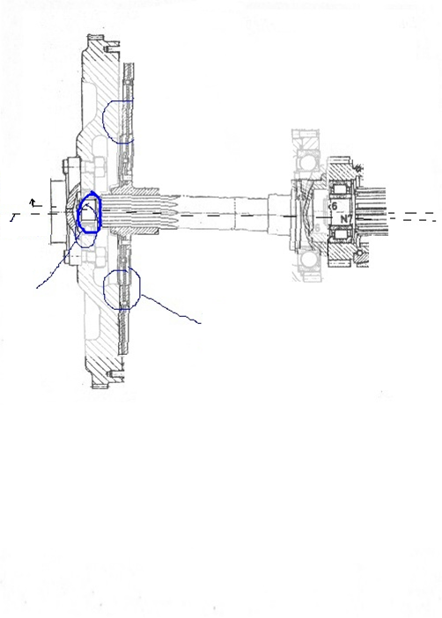
2 Wear areas
Shaft line 2
Shaft line 1
- 1.if 6305 bearing appeared clack to cause radial runout of input shaft guide-end of transmission, after input shaft miss guide function, Input shaft may clashed with 6395 bearing hole during clutch is running, Shaft line of input shaft appeared variation(see the above figure(see the above figure)
- 2. Driven disc of clutch wear with flywheel when input shaft appeared radial runout

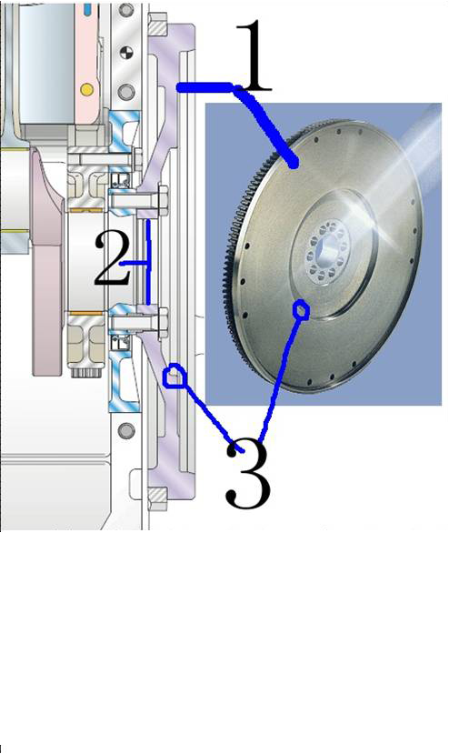
Section view of flywheel and side view
1. Work end-face of flywheel
2. 6305-2rs1 guide bearing position
3. Transition area of plane of flywheel bolt hole and flywheel work face
During the operation of the engine, the direction of shaft shifting is more liable on going forward. When going uphill, the crankshaft will move backwards due to gravity. But if the vehicle is frequently driven on slope road, especially when reluctantly shifting down in going downhill or suddenly lifting up the clutch in starting with heavy load, the excessive impact load on the thrust plate will happen and may cause severe wear.
If the vehicle keeps running even after thrust plate dropping off, it will lead to the damage of guide bearing of the shaft and, further lead to the shifting and radial vibration of the shaft and cause the wear of shaft cap and release bearing seat and finally the paitial damage of clutch. Such kinds of accident are the individual failures of engine, gearbox and clutch, but they are interconnected To sum up, the basic cause of the accident is that, the crankshaft thrust plate of the engine drops firstly. The causes might be:
- The thrust pad is reversely mounted. When the thrust plate is to be installed, the correct installation is that, the side without oil groove should close to main bearing seat cover and another side with oil groove closes to the crankshaft side so as to allow the splashed oil to flow along the oil groove for lubrication, Thus wear between crankshaft and thrust plate will be reduced. If it is reversely installed and the side with oil groove closes to main bearing seat cover, no engine oil will flow to the thrust plate, and it would cause premature wear of thrust plate. The reversely mounted thrust pad, with its steel frame as a friction surface, together with the corresponding surface on the crankshaft, forms a motion pair. Steel-steel friction pair is thus composed. Meanwhile, because the side face with oil groove faces the motionless end, it cannot provide lubrication to the friction pair. Adversely, the oil will flow along the groove and worsen wear between the motion pair. After a short period of operation, the friction between crankshaft and thrust pad worsened, resulting in the dropping off of the thrust pad from the clearance and bending.
- Bad quality of the surface on the crankshaft thrust plate. Due to the reason caused by manufacturers, faults such as sand, scratch or collision may appear on the surface of thrust platte. If they were not removed before installation, they will damage the thrust plate and lead to quick wear.
- The quality of the surface of crankshaft thrust shoulder does not meet the requirement. The quality of the friction surface of thrust shoulder should be superior so as to enlarge the contact area with the thrust plate, enhance the load capacity, and improve lubrication and reduce wear. Otherwise, it is required to apply fine oil stone to polish it till the quality meets the requirement.
- The inefficient contact area between antifriction alloy of crankshaft thrust washer and crankshaft, or improper width of oil storage groove on thrust washer causes excessive wear of thrust washer.
- Bad condition of lubrication. If the vehicle runs quickly after starting in winter, in such occasion the lubricant does not yet reach the surface of thrust ring. Axial thrust force will easily cause dry friction between the rear thrust washer and the shoulder of the crankshaft, and thus leading to the burning and coherence of the thrust washer.
- Excessive wear of the thrust washer of crankshaft or the flanger bearing bush leads to the reduction of thickness of antifriction alloy.
- Improper operation. If the vehicle coasts for a long time downhill with neutral gear and then inertia are used to start engine, it will result in the axial shifting of the crankshaft, and thus increase the wear of the thrust washer, and eventually the dropping off thrust pad.
- In addition, for vehicles which have been parked for a long period of time, it is prohibited to move the vehicle immediately after starting up the engine. Because once the clutch pedal is stepped on, the crankshaft is liable to move forward. But sufficient lubrication is not reached yet and dry friction easily occurs in the thrust pad after force application, thus easily causing burning and damage.

